**Poverty threatens ever more people in Germany**

The past 10 years have seen an increasing number of people in Germany at risk of falling below the poverty line. In one large city, nearly a quarter of residents fall into this category.

[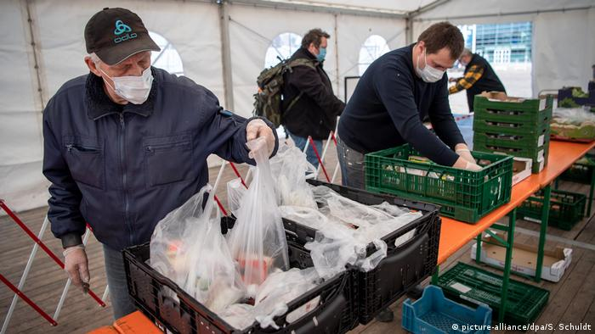](https://www.dw.com/en/poverty-in-germany-on-the-rise/a-54553080)

The number of people at risk of falling into poverty in Germany has risen in all the [country's western states](https://www.dw.com/en/poverty-among-senior-citizens-is-worse-in-western-germany/a-50547365) and Berlin over the past decade, according to government figures released on Thursday.

In total, 15.9% of Germany's population is at risk of falling below the poverty threshold — up from 15.5% the year before, the Federal Statistical Office found.

The government classifies someone as being at risk of falling into poverty if their [income is less than 60% of the average](https://www.dw.com/en/germanys-minimum-wage-is-barely-above-the-poverty-line/a-46797781). In 2019, this was calculated as less than €1,074 ($1,271) each month.

*Read more:* [1 in 5 children in Germany grow up in poverty](https://www.dw.com/en/1-in-5-children-in-germany-grow-up-in-poverty/a-54260165)

The outlook for people in the at-risk category could be set to worsen, after 6.7 million people were furloughed and thousands lost jobs during the coronavirus pandemic.

A decade of rising poverty

The northern city of Bremen reported the largest percentage of people at risk of poverty at 24.9%. This was a ten-year increase from 20.1% of its population.

Germany's most populous state, North Rhine-Westphalia, saw the percentage of those in the at-risk group grow from 15.2% in 2009 to 18.5% last year.

*Read more:* [Homelessness in Germany on the rise](https://www.dw.com/en/homelessness-in-germany-on-the-rise/a-51195787)

In Hesse, home to the financial hub of Frankfurt, the figure rose from 12.4% up to 16.1% in the same time period.

The southern states of Bavaria and Baden-Württemberg had the lowest rates, at 11.9% and 12.3%. Nevertheless, this represented an increase as well.

References

Deutsche Welle (www.dw.com). (n.d.). Poverty threatens ever more people in Germany. DW.COM. Retrieved January 15, 2022, from <https://www.dw.com/en/poverty-in-germany-on-the-rise/a-54553080>

(Deutsche Welle (www.dw.com), n.d.)